- Purpose
  - The purpose of this document is to describe the procedure for assembling a shroud for a propane machine with dust control.
- Scope
  - This SOP applies to all equipment assembly team members. The process applies to the following machines:
E012850EQM0600BE1200 – 27” Optima XR w/ Dust Control
E012860EQM0600BE1200 – 27” Optima XR w/ Clutch & Dust Control
E012865EQM0600BE1200 – 27” Optima XR w/ Emissions & Dust Control
E012875EQM0600BE1200 – 27” Optima XR w/ Emissions, Clutch, & Dust Control
- Responsibilities
  - The operations manager/supervisor is responsible for enforcing this SOP.
- Materials
  - The proper materials needed for this process are listed on the sub-assembly work order.
  - Hand/Power Tools
  - Drill Fixture
- Definitions

- Procedure
  - Locate the dust skirt drill fixture. Two dust skirts (88986) will be drilled out during this step.

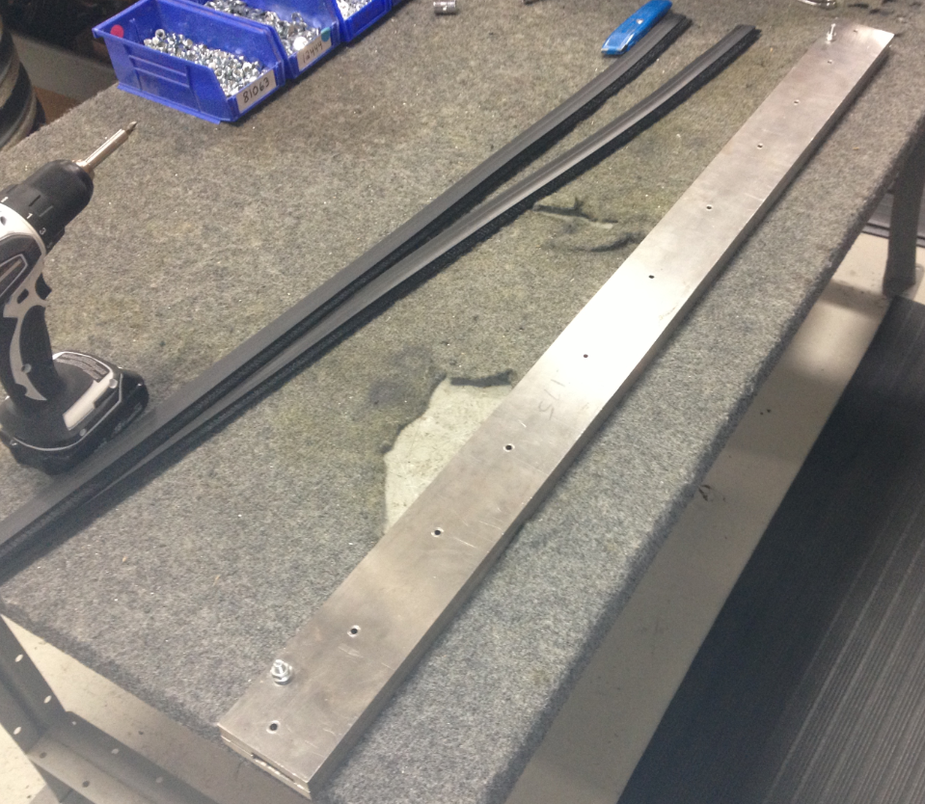

  - Loosen the two nuts on the fixture and slide a skirt all the way into it until the ends line up with the ends of the fixture. The skirt will only fit in one way.

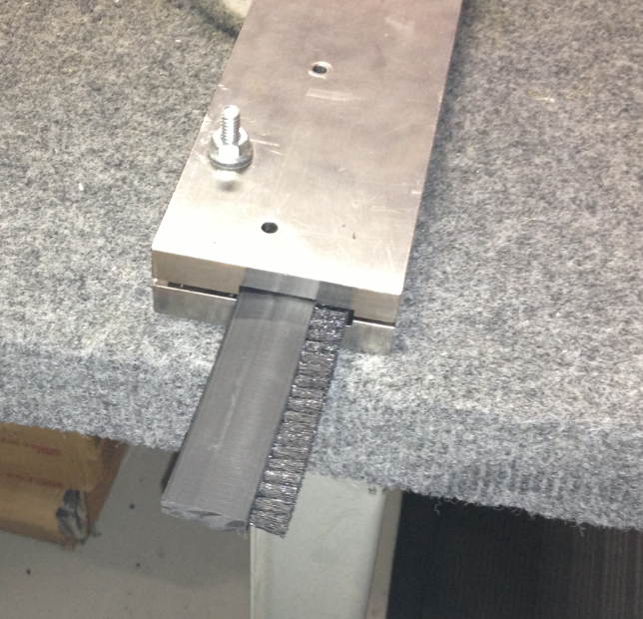

  - Slightly tighten the nuts to hold the skirt in place.

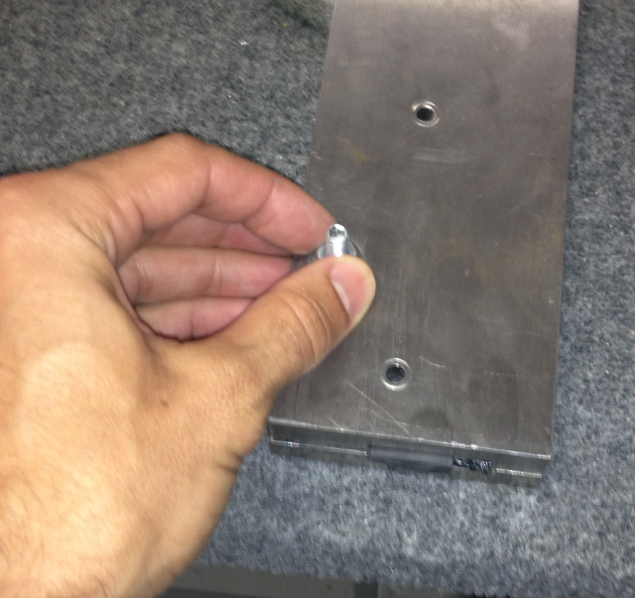

  - Use a 3/16” drill bit and transfer the holes into the skirt. There are more holes in the fixture than what need to be drilled. Start with the hole on the end and drill every other hole. There will be 6 holes per skirt.

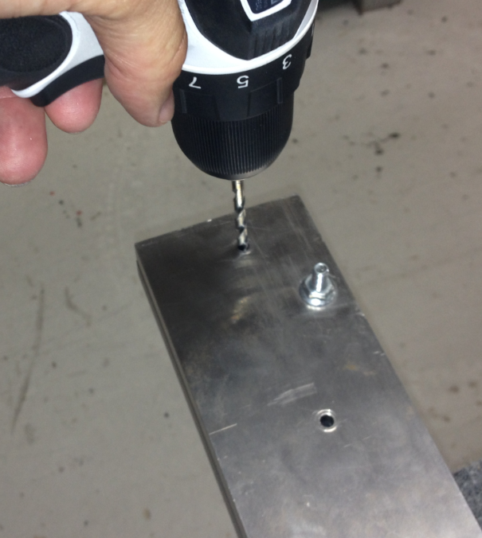
  - Repeat for the 2nd skirt.
  - Line the end of one of the skirts up with the port on a shroud (88984) as shown and install it working from one end to the other. Be sure that the skirt is completely installed onto the shroud.

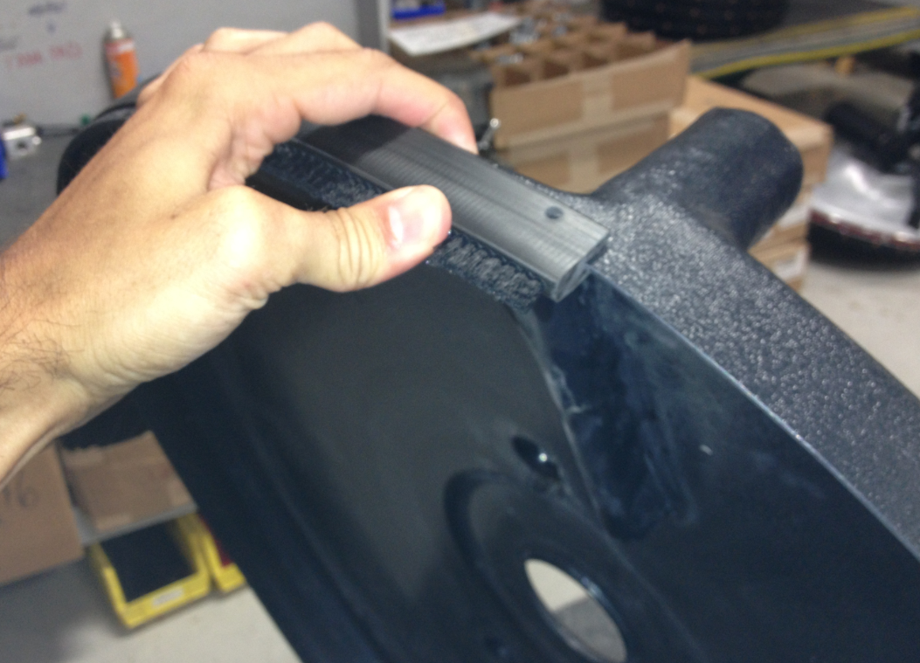

  - Install the 2nd skirt as shown.

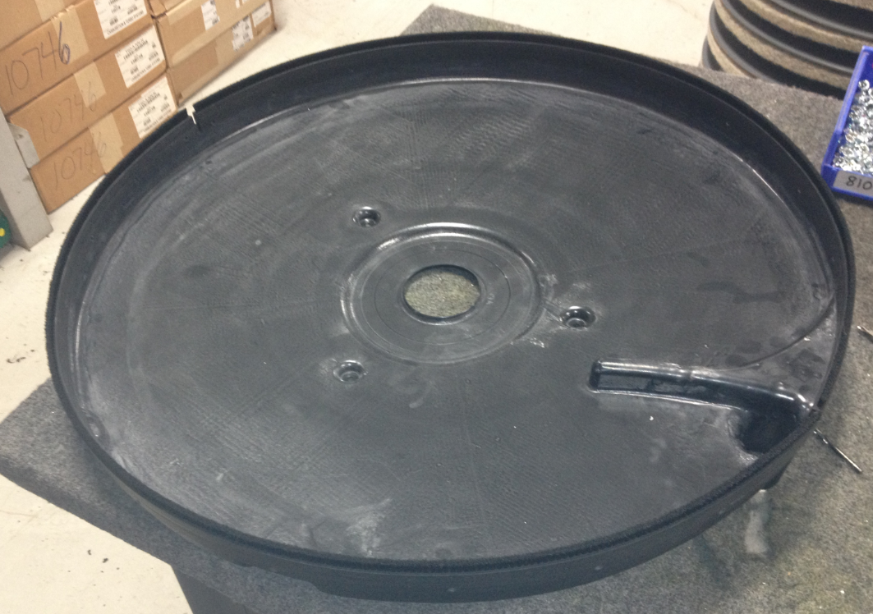

  - Use the same 3/16” drill bit to transfer the holes from the skirt through the shroud as shown. The holes should be roughly on the center of the shroud.

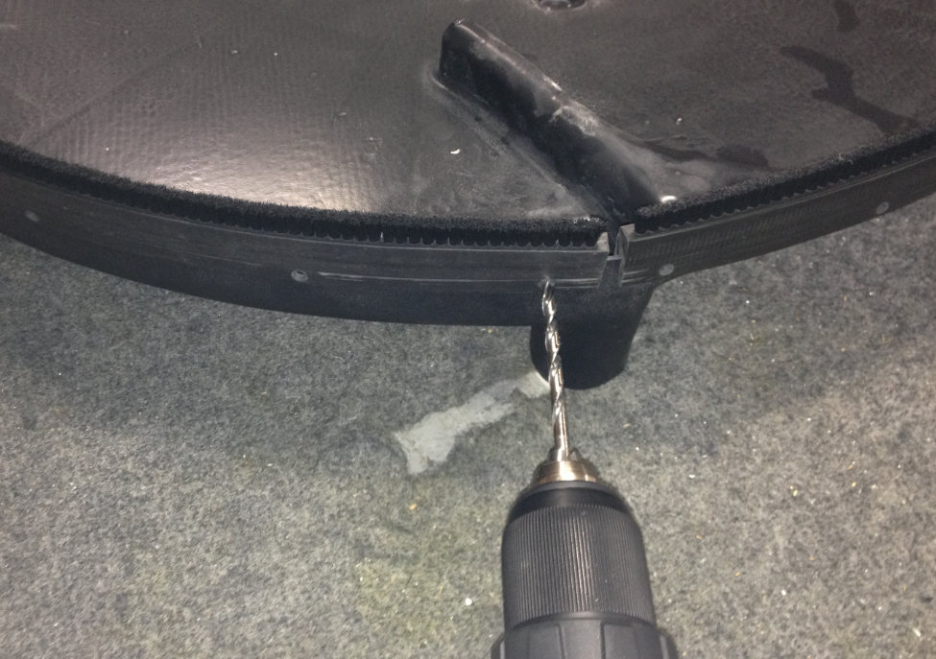

  - Fasten the skirt to the shroud using the copper rivets (89638) shown. Each rivet set consists of the rivet and a washer.

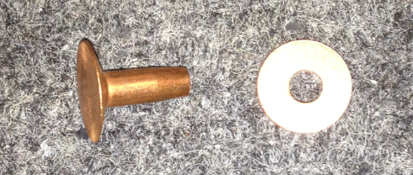

  - Install the rivet through the hole so that the head of it is on the outside of the shroud. Place the washer over the end of the pin on the inside.

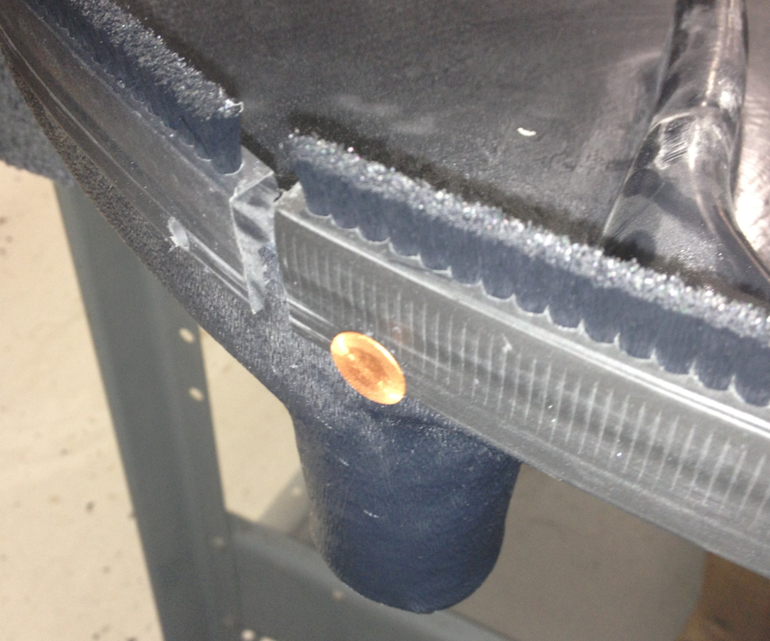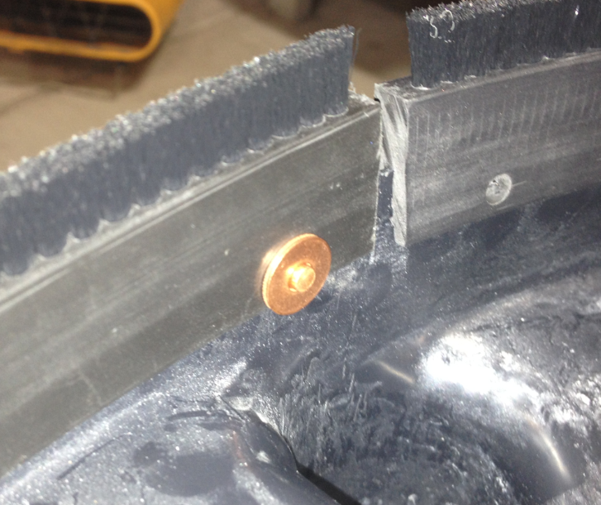
  - Locate the rivet crimping tool. Note that one of the dies has a cutout on it. That is where the pin on the rivet goes.

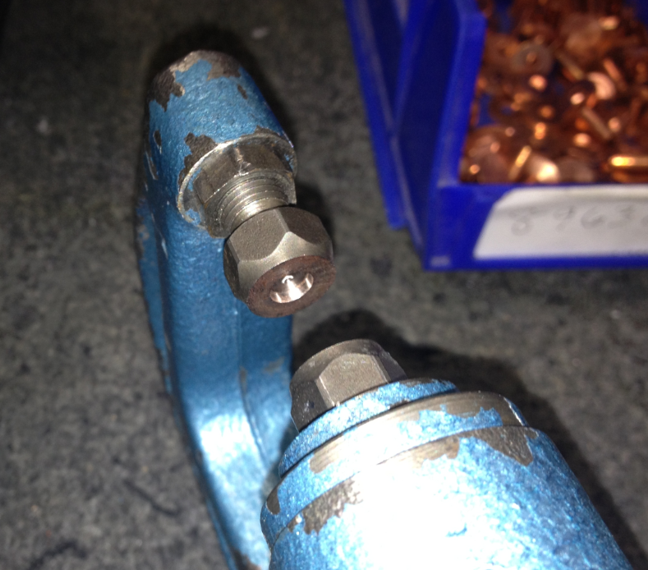

  - Center the crimper tooling over the rivet. Be sure the washer does not fall off. Crimp the rivet into place. Be sure that a good crimp was made and that the washer does not fall off. Repeat if necessary.

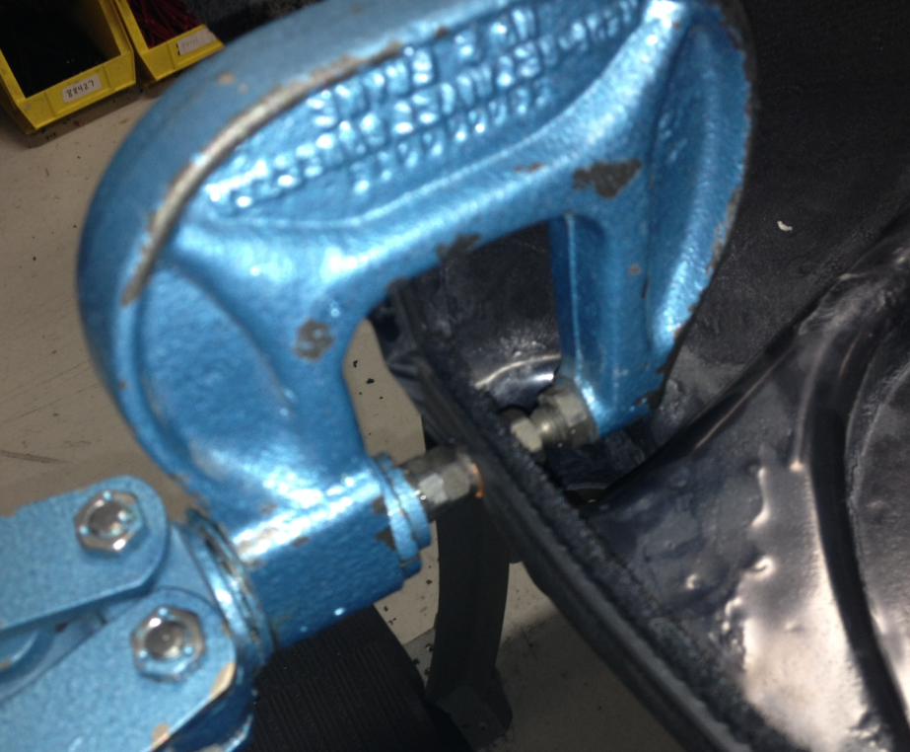
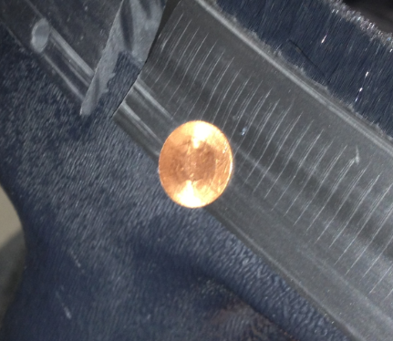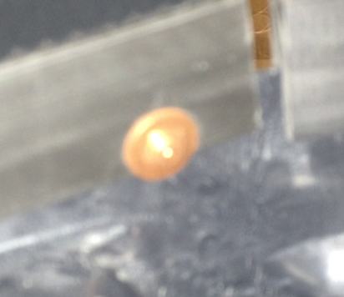

  - Repeat for all holes on the shroud.

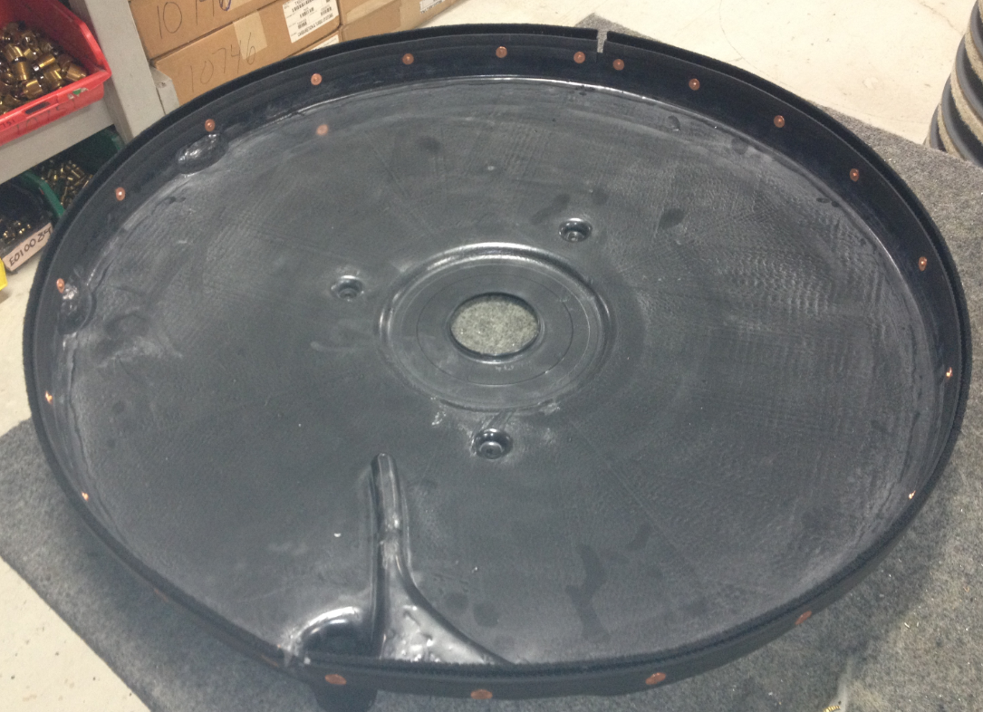

- References (optional section as needed)

- Training Guide

Functional Training Groups Requiring Training
Equipment Assembly Group

- SOP Change Control

Date of Change | Reason for Change
Rev 01 - 11/19/2013 | This is the first version of the S.O.P. hence there are no revisions to this document.
Rev 02 - 1/12/2018 | Added the Responsibilities Section
Rev 03 - 5/4/2018 | Updated the machine ID’s for the Optima XR
Rev 04 - 3/21/2025 | Removed work center notes

Approvals

Submitter/Author Approval:__________________________________ Date:______________________

Management Approval:______________________________________ Date:______________________

QAU Approval:_____________________________________________ Date:______________________

